**EKS**

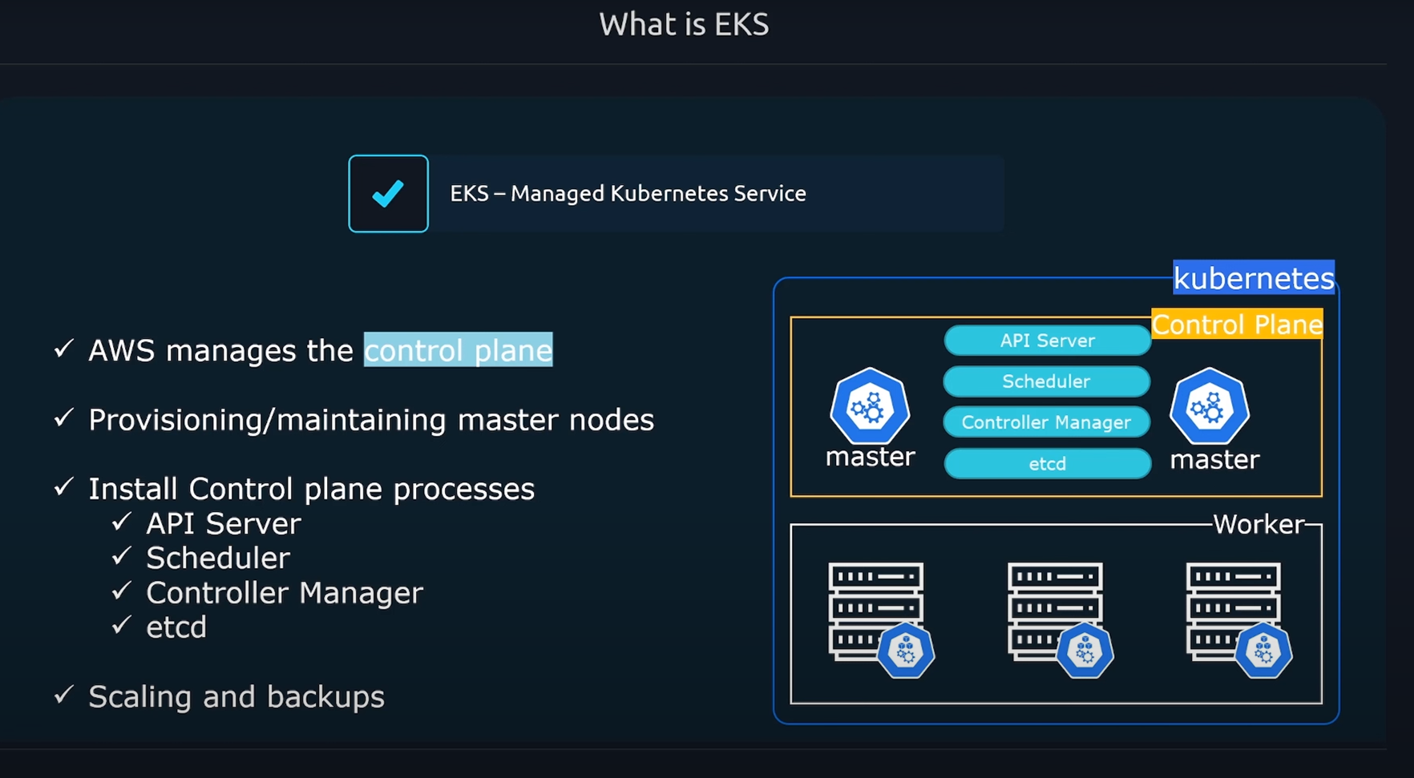

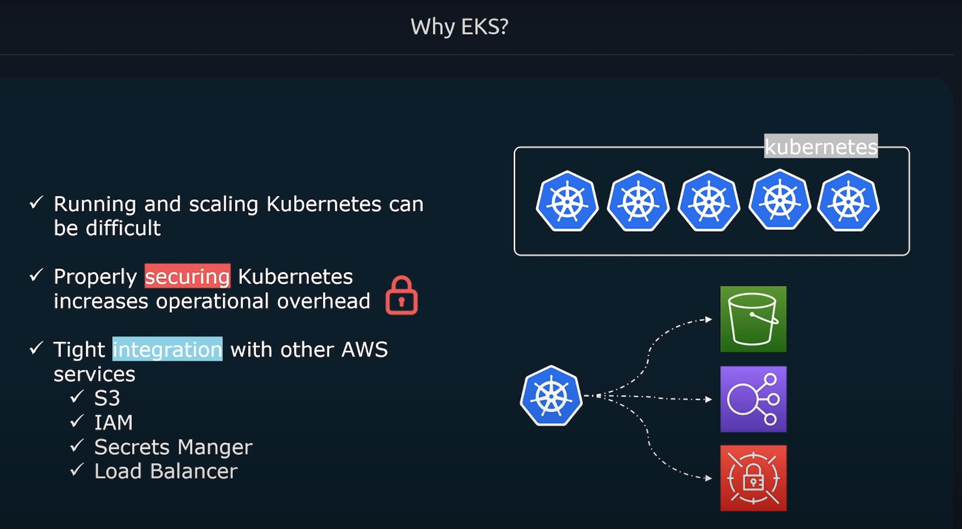

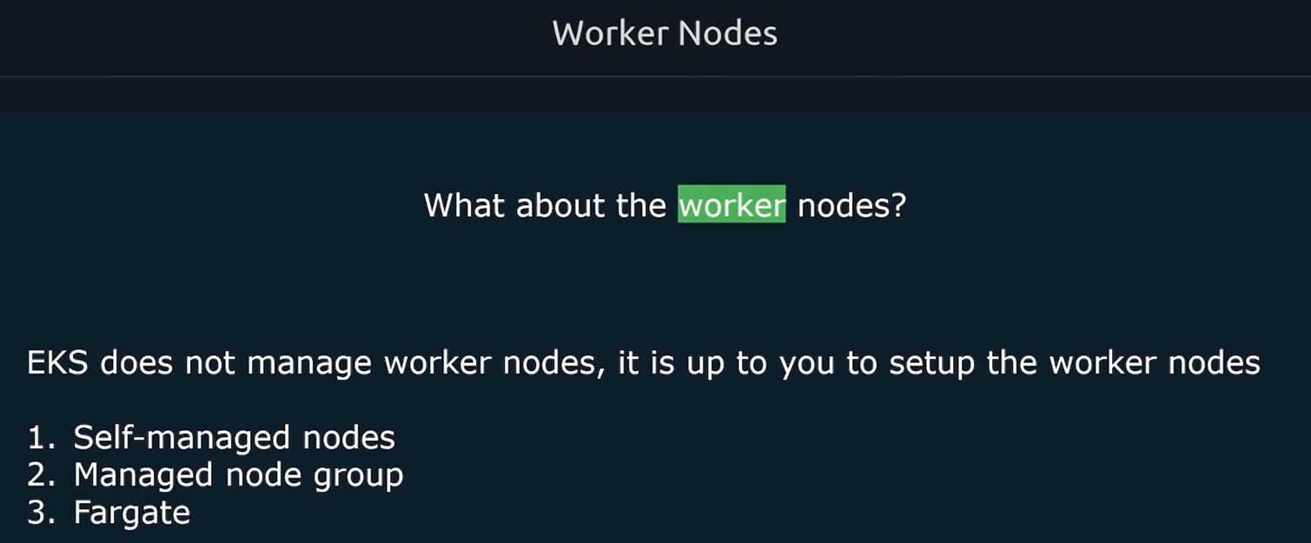 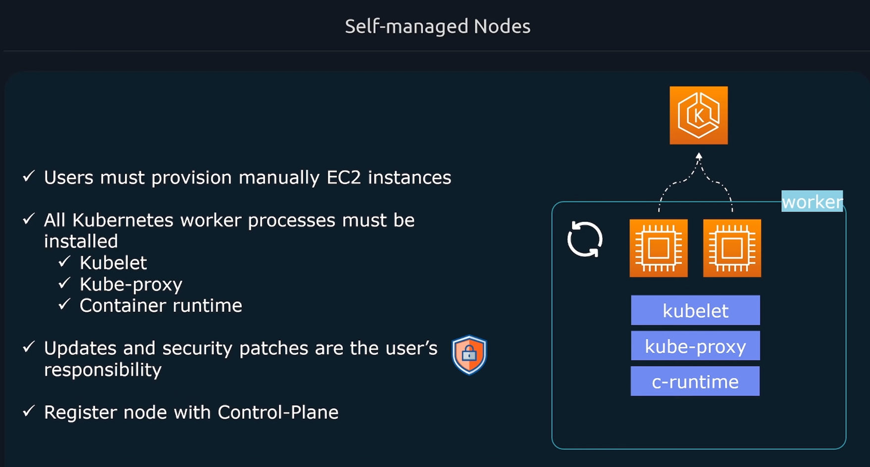

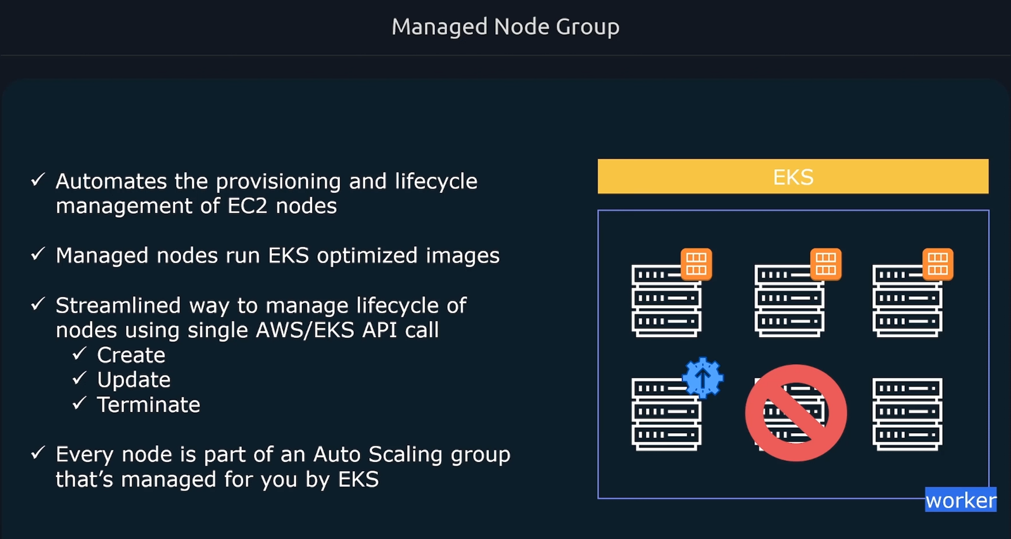

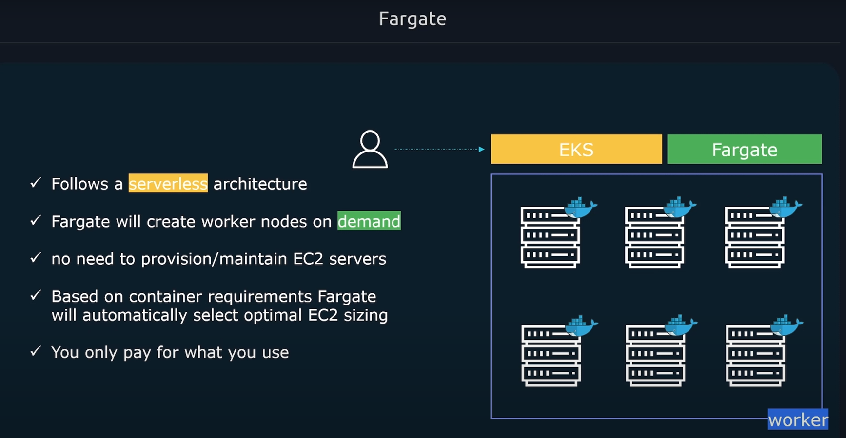

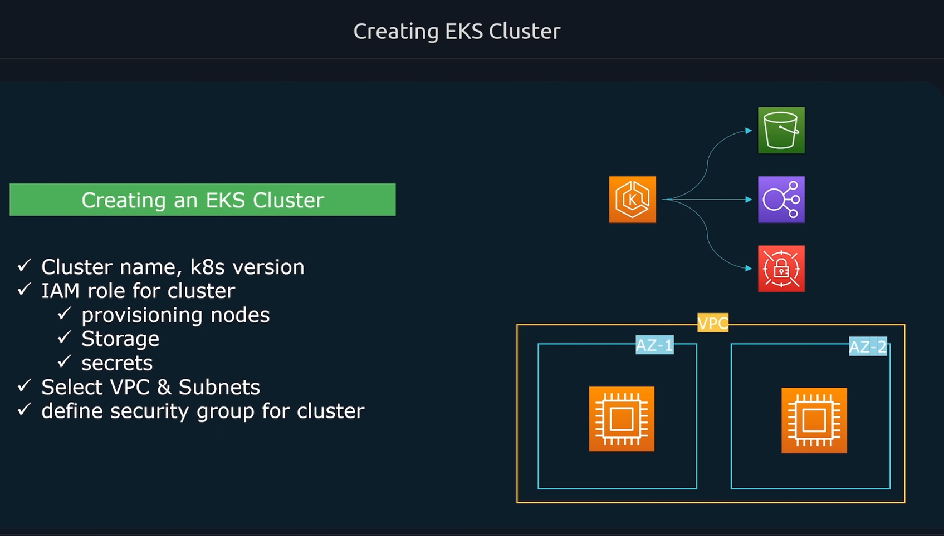

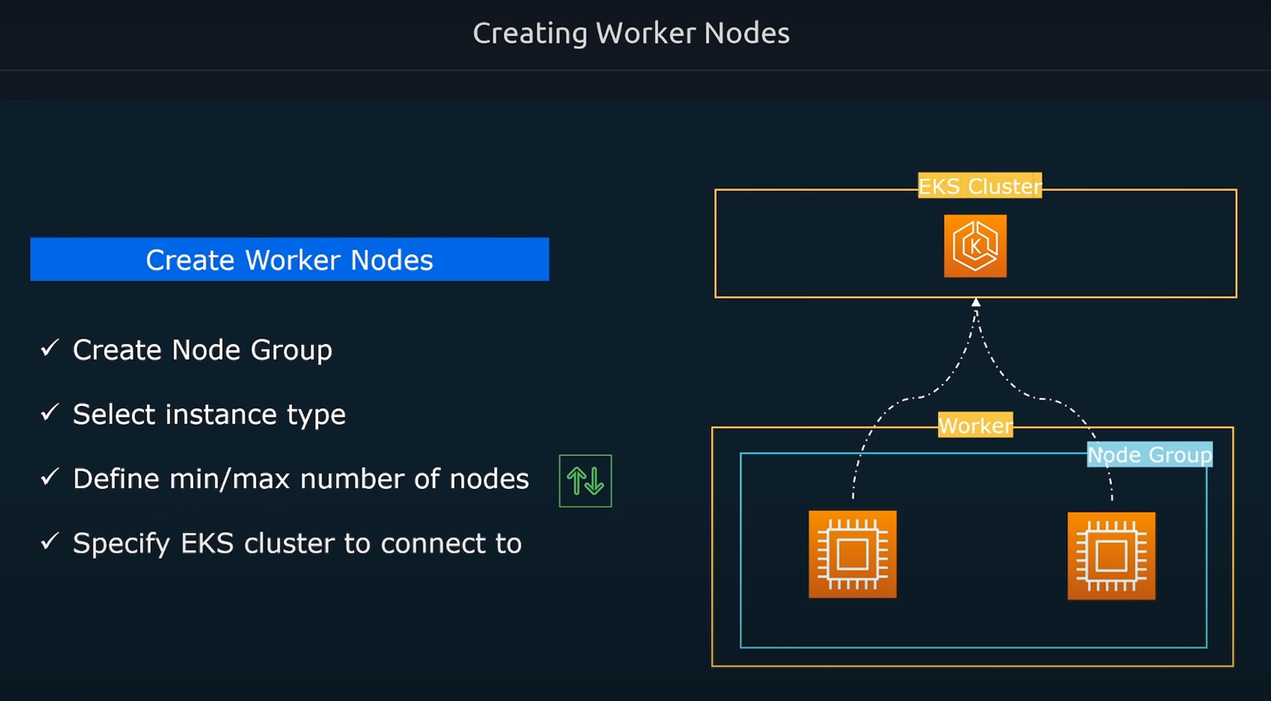

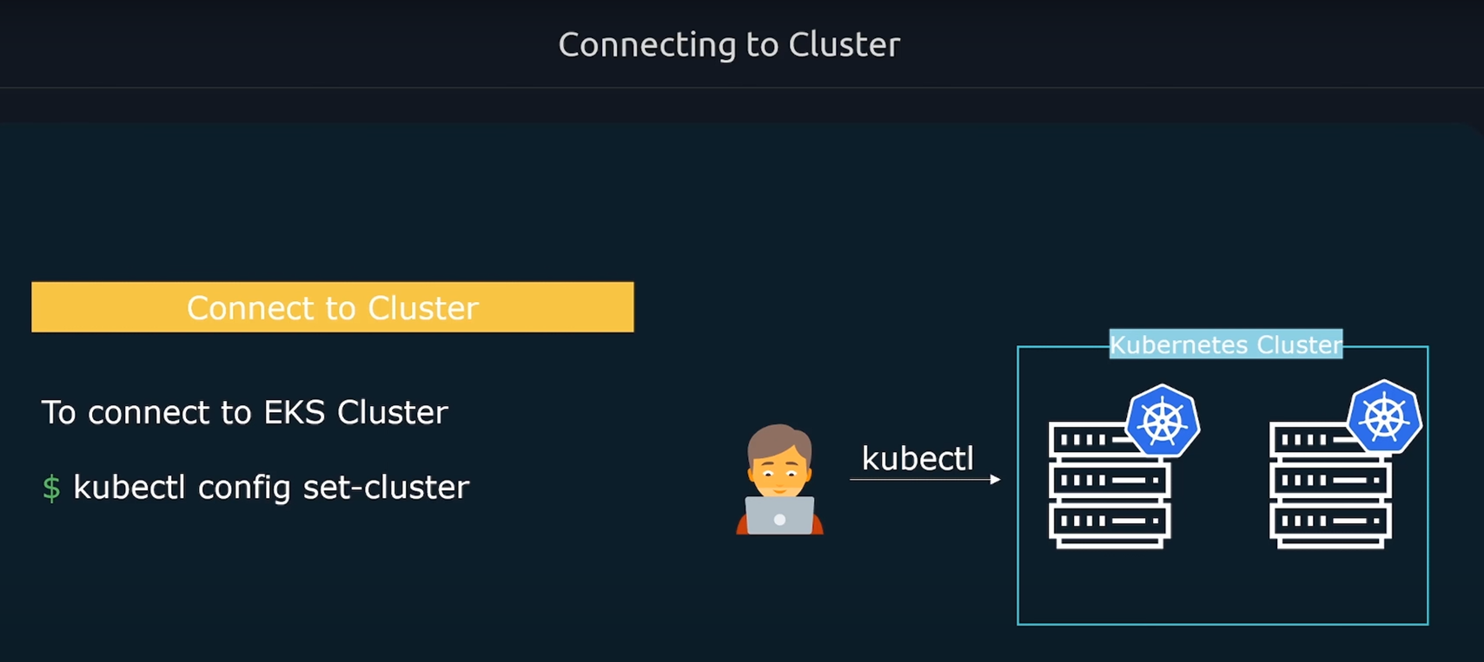

* Different ways to create a cluster
  + Using AWS cluster

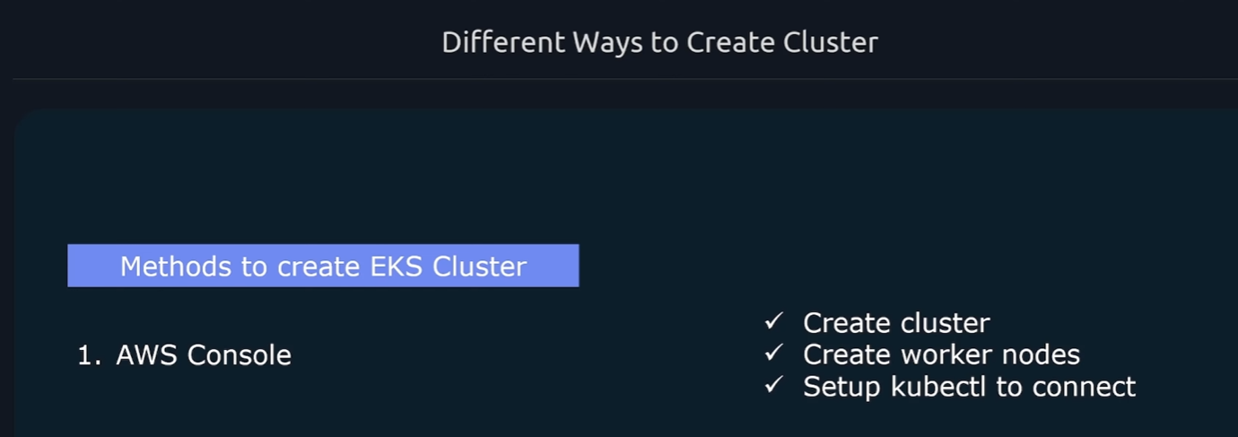

Although, using AWS console is easy but it’s a little bit of long and complex process. You have to create EKS cluster, worker nodes, setup kubectl in your local system to be able to connect to the cluster. Also, provision VPC, subnets and handling routing.

* + Use Eksctl: A tool developed by Weaveworks.

Just run the command “eksctl create cluster”, it will provision VPCs, clusters, subnets, etc

To delete a cluster, just run “eksctl delete cluster”.

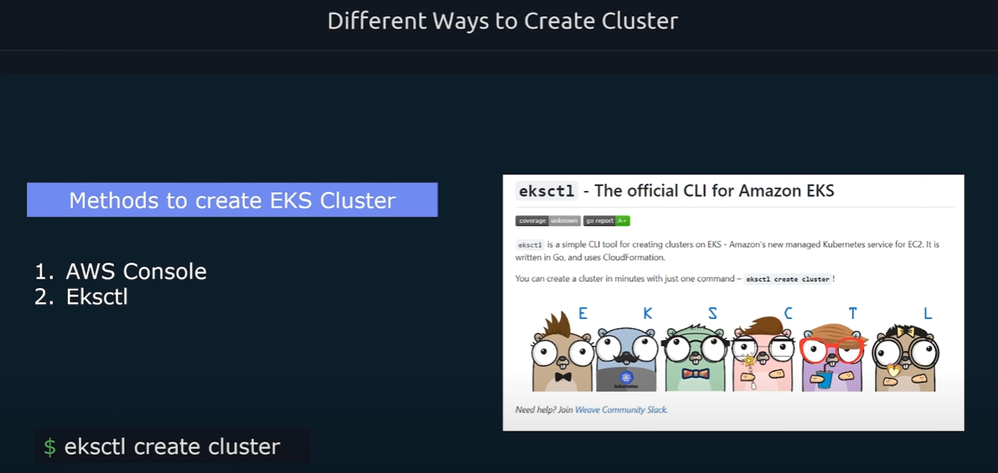

* + Use IaaC tools:

Use IaaC tools like Terraform or Pulumi and that way you can define infra config in codes and you can deploy that using Terraform or Pulumni

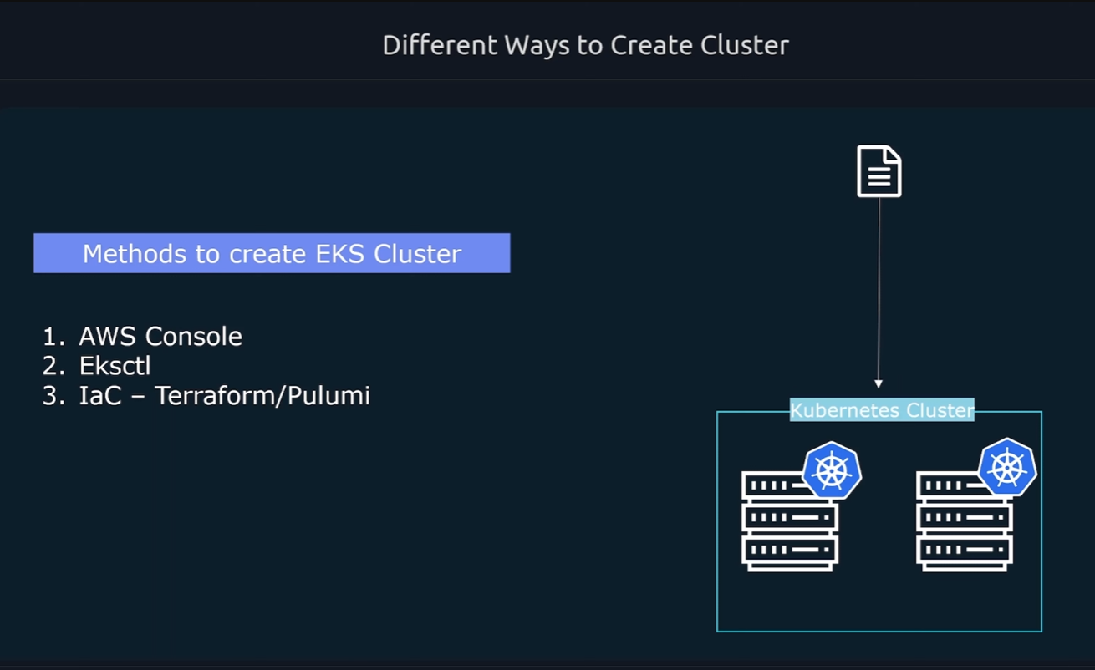

* Install Eksctl:
  + Go to amazon eks documentation <https://docs.aws.amazon.com/eks/latest/userguide/eksctl.html>
  + Run the following commands to install
    - curl --silent --location "https://github.com/weaveworks/eksctl/releases/latest/download/eksctl_$(uname -s)_amd64.tar.gz" | tar xz -C /tmp
    - sudo mv /tmp/eksctl /usr/local/bin
    - 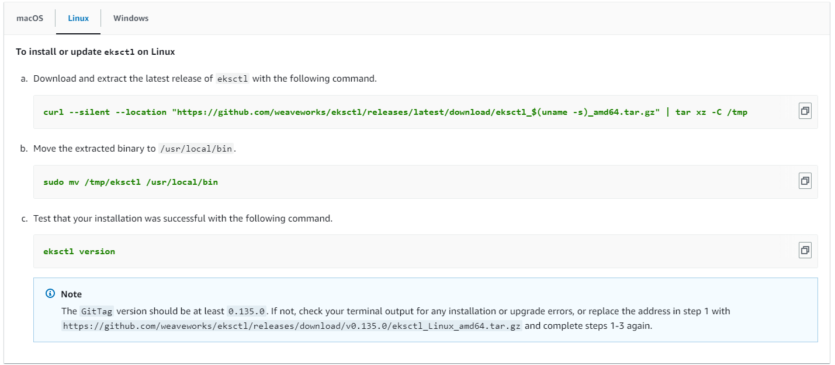eksctl version
* Setup authentication for the tool so that it can talk to the AWS API and configure resources within our account
* An example of eksctl create
* To delete and eks cluster, use command

eksctl delete cluster --name ekscluster1